Programming with python
chathurya krishna k s
ECE CL2
Program 1
write a program to draw a graph of one line

mport matplotlib.pyplot as plt
x = [1,2,3]
y = [2,4,1]
plt.plot(x,y)
plt.xlabel('x-axis')
plt.ylabel('y-axis')
plt.title('my first graph')
pit.show(0
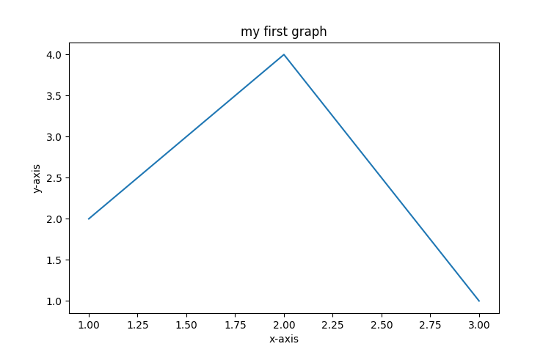

program 2

write a program to make a graph of two lines

import matplotlib.pyplot as plt

x1 = [1,2,3]
y1 = [2,4,1]

plt.plot(x1, y1, label = "line 1")

x2 = [1,2,3]
y2 = [4,1,3]
plt.plot(x2, y2, label = "line 2")
plt.xlabel('x - axis')
plt.ylabel('y - axis')
plt.title('Two lines on same graph!')
plt.legend()
plt.show()

output

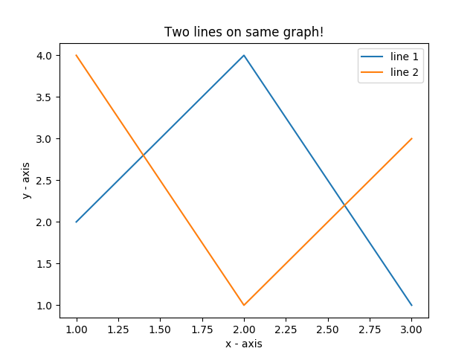

PROGRAM 3

write a program to draw a graph of dashed lines

import matplotlib.pyplot as plt
x = [1,2,3,4,5,6]
y = [2,4,1,5,2,6]
plt.plot(x, y, color='green', linestyle='dashed', linewidth = 3,
marker='o', markerfacecolor='blue', markersize=12)
plt.ylim(1,8)
plt.xlim(1,8)
plt.xlabel('x-axis')
plt.ylabel('y-axis')
plt.title('Some cool customizations!')
plt.show()

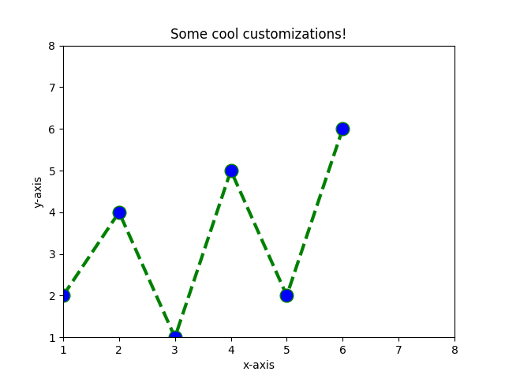
program 4

write a program to draw a bar graph

import matplotlib.pyplot as plt

left = [1, 2, 3, 4, 5]

height = [10, 24, 36, 40, 5]

tick_label = ['one', 'two', 'three', 'four', 'five']

plt.bar(left, height, tick_label = tick_label,
width = 0.8, color = ['red', 'green'])

plt.xlabel('x - axis')
plt.ylabel('y - axis')
plt.title('My bar chart!')

plt.show()

output

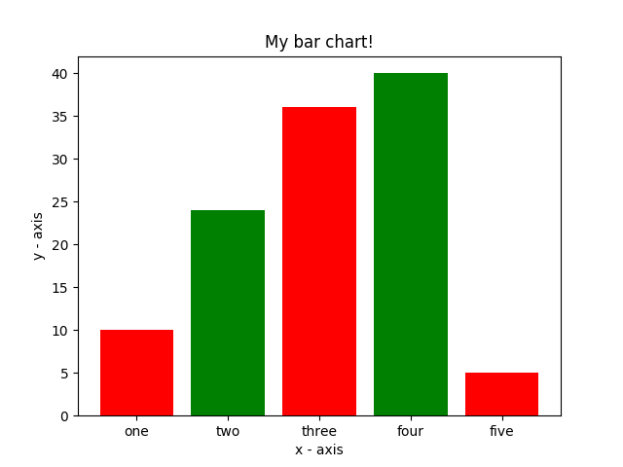
program 5

write a program to draw a bar graph of number of people and their ages

import matplotlib.pyplot as plt
ages = [2,5,70,40,30,45,50,45,43,40,44,
60,7,13,57,18,90,77,32,21,20,40]

range = (0, 100)
bins = 10

plt.hist(ages, bins, range, color = 'green',
histtype = 'bar', rwidth = 0.8)

plt.xlabel('age')
plt.ylabel('No. of people')
plt.title('My histogram')

plt.show()

output

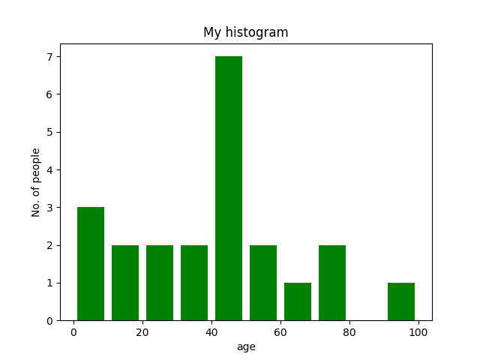

program 6

write a program to draw a bar graph with using legend function

import matplotlib.pyplot as plt

x = [1,2,3,4,5,6,7,8,9,10]
y = [2,4,5,7,6,8,9,11,12,12]

plt.scatter(x, y, label= "stars", color= "green",
marker= "*", s=30)

plt.xlabel('x - axis')
plt.ylabel('y - axis')
plt.title('My scatter plot!')
plt.legend()

plt.show()

output

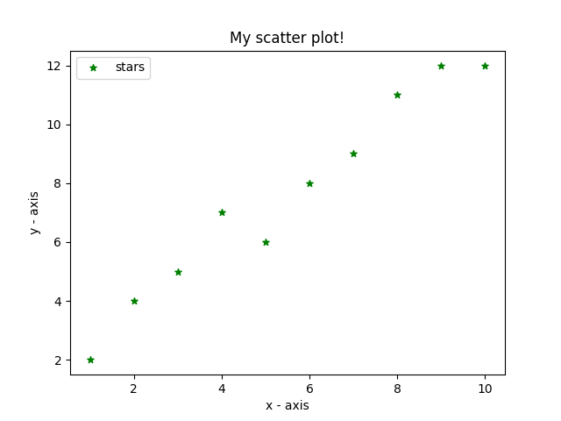

program 7

write a simple program using bar graph

import matplotlib.pyplot as plt

ages = [2,5,70,40,30,45,50,45,43,40,44,
60,7,13,57,18,90,77,32,21,20,40,43,76,98,6743,32,67,21]

range = (0, 100)
bins = 10

plt.hist(ages, bins, range, color = 'blue',
histtype = 'bar', rwidth = 0.8)

plt.xlabel('age')
plt.ylabel('No. of people')
plt.title('My histogram')

plt.show()

output

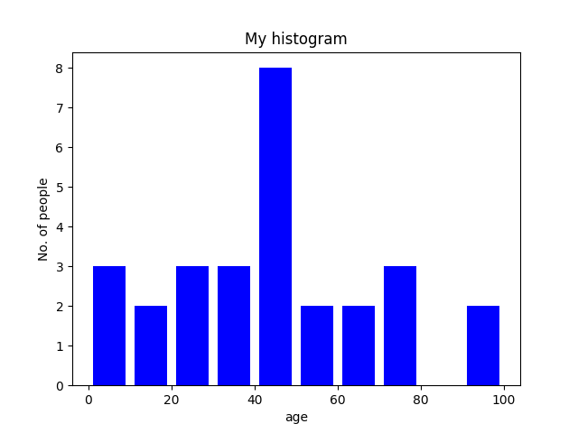

program 8

write a program to draw a pie chart

import matplotlib.pyplot as plt

activities = ['eat', 'sleep', 'work', 'play']

slices = [3, 7, 8, 6]

colors = ['r', 'y', 'g', 'b']

plt.pie(slices, labels = activities, colors=colors,
startangle=90, shadow = True, explode = (0, 0, 0.1, 0),
radius = 1.2, autopct = '%1.1f%%')

plt.legend()

plt.show()

output

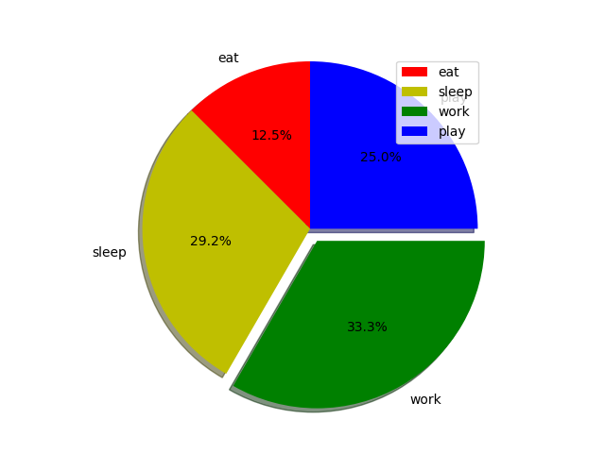
program 9
write a program to draw a graph of wave

mport matplotlib.pyplot as plt
import numpy as np

x = np.arange(0, 2*(np.pi), 0.1)

y = np.sin(x)

plt.plot(x, y)

plt.show()

output

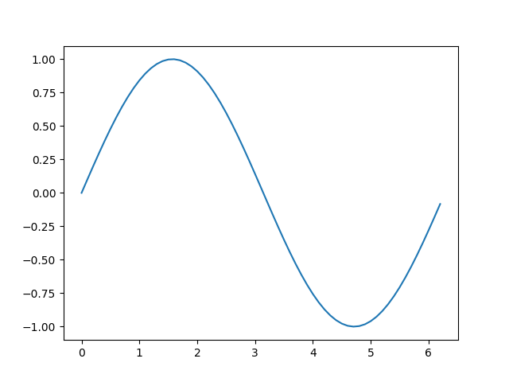

program 10

write a program to draw a graph

import matplotlib.pyplot as plt
import numpy as np
x = np.arange(0.0, 2.0, 0.01)
y = x**2
dy = 2*x - 1
plt.plot(x, y)
plt.plot(x, dy)
plt.plot(1, 1, 'or')
plt.title('A Cool Graph')
plt.xlabel('X')
plt.ylabel('Y')

plt.grid(True)
plt.legend(['y = x^2', 'y = 2x'], loc='upper left')

plt.show()

output

